**mPlayer v2 – HCI Projekat #2**

Uputstvo za upotrebu (EN)

*Ognjen Komadina 1163/20*

*Elektrotehnički fakultet*

*Univerzitet u Banjoj Luci*

1. Application description

*mPlayer* is a simple music player which consists of two basic use cases: playing a single song, or a playlist. The application base language is English, and therefore this guide is too. Main user controls are play/pause button, stopping the current song and/or skipping to the next song (if a playlist is loaded and there are songs queued).

1. Usage guide
   1. 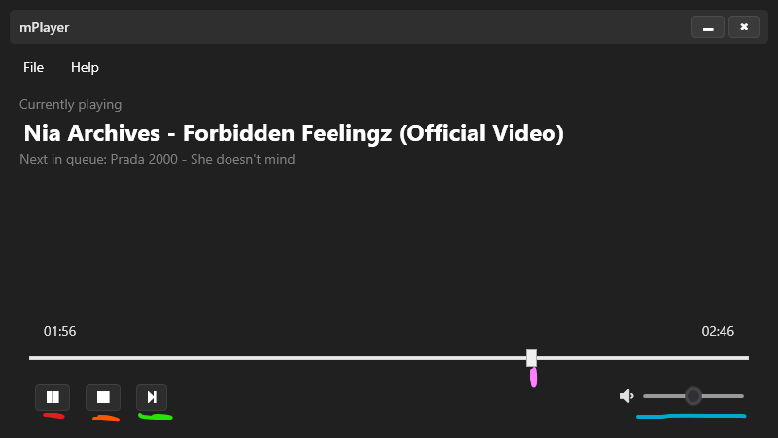Basic controls

The main user controls are underlined on the picture, shown above. The **play/pause** button serves the logical purpose of temporarily play/pausing the current song playback – underlined with red color. The **stop** button serves the purpose of stopping the playback of the current song. Naturally, if there are other songs in the playlist, it will automatically dequeue and begin playback. Keeping in mind the previous case, the **play-next** button serves the purpose of user interface friendliness, to indicate that another song can be skipped to. The **volume** slider is set to a default value of 50% of it’s maximum – drag the slider to adjust. The **seek-slider** thumb allows the user to drag onto a song position that they would like to seek the current song to. There are also two labels at the bottom: the current seek time (left, pictured 01:56) and the song length (right, pictured 02:46).

* 1. Loading a song

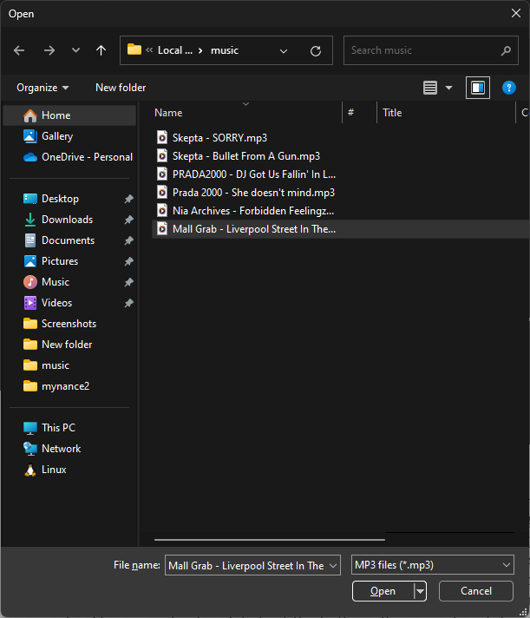To load a song of your liking, you can either: navigate to the 'File' dropdown menu and select 'Load song', or simply press **CTRL+O** on your keyboard to open the file picker dialog. Upon choosing a song you’d like, press on the ‘Open’ button, in the lower left.

* 1. Loading a playlist

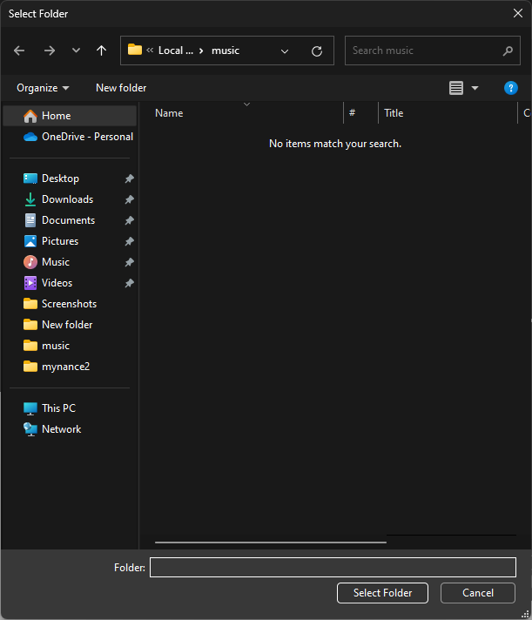To load a playlist of your liking, defined as a list of songs within a directory, you can either: navigate to the 'File' dropdown menu and select 'Load directory', or simply press **CTRL+K** on your keyboard to open the folder picker dialog. Upon choosing a song you'd like, press on the 'Select Folder' button, in the lower left.

*Note: due to system limitations, the list of songs (or files, in general) are not able to be shown.*